**ONLINE AIRLINE RESERVATION SYSTEM**

**QUESTION:**

Make an Online Airline Reservation System. The activities of the Online Airline Reservation system are listed below user, admin, LOGIN, MANANGE CLASSES, MANANGE WAITING LIST, MANAGE HOLDS, MANAGE DEADLINES, LOGOUT, using this has a step-by-step process draw a CLASS diagram.

**AIM:**

To develop a Class Diagram for an Online Airline Reservation System that includes users, admins, and various management functionalities such as login, managing classes, waiting lists, holds, deadlines, and logout.

**PROCEDURE:**

1. Identify classes: User, Admin, Reservation System.

2. Define attributes & methods for each class.

3. Establish relationships between classes.

4. Draw the Class Diagram with attributes, methods, and associations.  
**DIAGRAM:**

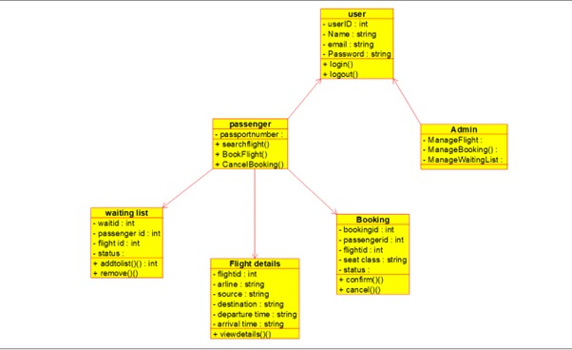

**RESULT:**

A Class Diagram for the Online Airline Reservation System was successfully created.